

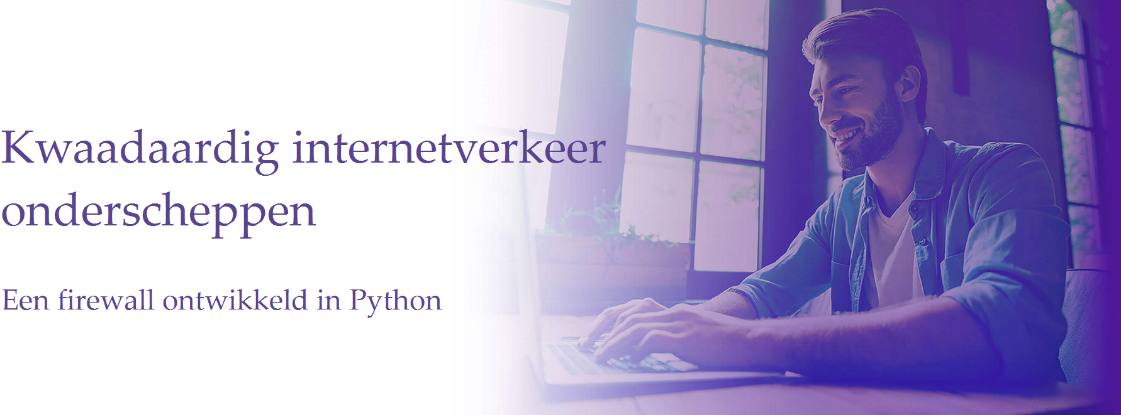

Kenzo Staelens

Jonathan van Caloen

Jonas Van den Berghe

Michaël Vasseur

Bachelor Elektronica-ICT Mentor: Tom Cordemans

2022-2023





Kenzo Staelens

Jonathan van Caloen

Jonas Van den Berghe

Michaël Vasseur

Bachelor Elektronica-ICT Mentor: Tom Cordemans

2022-2023

Malicious Internet traffic interception   
K. Staelens, J. van Caloen, J. Van den Berghe, M. Vasseur  
  
This project investigates a way to intercept malicious internet traffic and how a solution can be provided, with an aim for ease of use. By using a webserver as a gateway and a firewall build on software developed in python. Emphasis is placed on the third and fourth network layers.

In the first chapter regarding malware is given to understand how malware works. Types of attacks and what effect they have are discussed here. Understanding how it works is a baseline to prevent malicious software from infecting a system and helped develop a solution. Subsequently the existing solutions are described and compared. The next chapter discusses the criteria for efficient malware interception and blocking.

From all the known data, a firewall will be developed that will efficiently analyze the network traffic and throw up the necessary actions. The coming chapters cover the technical side of the solution, aiming to provide a look at the firewall coded in python with a user-friendly interface. Responding to the end user's demand for ease of use.

In the final chapter the evaluation of the project is described. The pros and cons of combining this solution with artificial intelligence for a possible sequel are also stated.

Keywords: Firewall, infrastructure, packet analyser, webserver, malware, artificial intelligence, user-friendly interface

Hier verder …